Assignment no: 8
Once your browser is logging pre-master keys, it’s time to configure Wireshark to use those logs to decrypt SSL
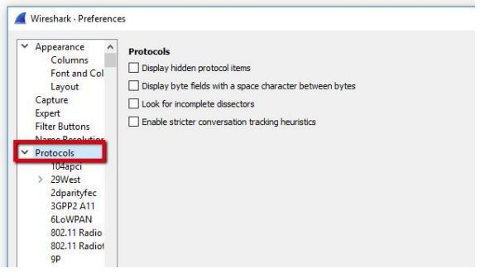
Open Wireshark and click Edit, then Preferences. The Preferences dialog will open, and on the left, you’ll see a list of items. Expand Protocols, scroll down, then click SSL
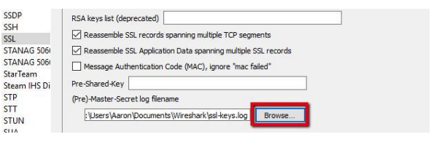

The final step is to capture a test session and make sure that Wireshark decrypts SSL successfully
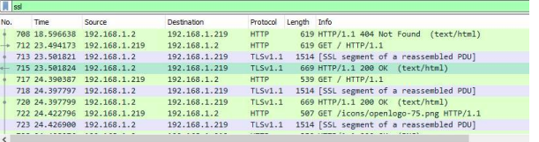
Once you’ve selected an encrypted data frame, look at the Packet byte view, and specifically the tabs underneath the view. You should see an entry for Decrypted SSL data, among other
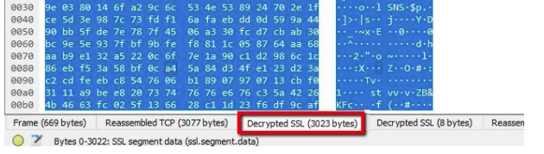
You’ll notice that my session still looks like it’s full of garbage, and no HTML is visible. That’s because my web server (and most Apache servers) use GZIP compression by default
